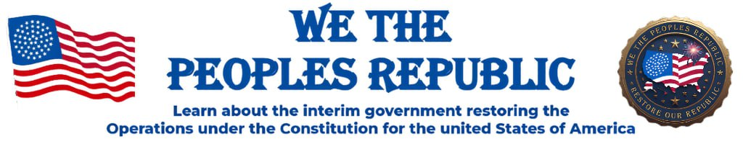
Newsletter
October 19, 2025

One Nation Under God

“Where patriots come to take back their country”.
(but we can’t TAKE BACK, until we’re willing to STAND UP)

www.wethepeoplesrepublic.org


Whether you are a new member or a long-time follower of our founder Tim Turner, please know you are in the right place, and we are honored you chose to be here…WELCOME!
This newsletter is for the people and by the people and our intent here is to be the voice of the people.
There are of course other platforms for communications like the website and our online Telegram channel (WeThePeoplesRepublic).
This Newsletter is but another way for you to stay informed and engaged in the process of “taking back our country”.
FOR NEW MEMBERS: If you would like some additional information on the WTPR’s vision, mission, goals, background and more, please send me a note at: newsletter@wethepeoplerepublic.org

.
Newsletter Volunteers

Following is a list of ‘We the People’s Republic’ members who serve as volunteers to help make the newsletter a reality:
- Mike Schnaufer, editor and publisher / volunteer Mo.
- Janice Williams, contributing researcher & writer / volunteer Ok.
- Fred Pena, delivers newsletter to all members webmail / volunteer Ca.

Christians in Civil Government – Part 5
(Authored and submitted by Janice Williams, volunteer Oklahoma; as summarized from the book “The Role of Pastors & Christians in Civil Government”
By David Barton)

Part 5 of 5: A Call to Action

Pastors: Boldly Speak the Truth
- Pastors are entrusted with shepherding both souls and consciences.
- Silence in the pulpit leads to confusion in the culture.
- History shows that when pastors speak clearly on moral issues, the nation benefits.
Challenge: Preach the whole counsel of God, applying Scripture to both personal and civic life.

Christians: Step Into Civic Responsibility
- Every believer has a part to play:
◦ Vote prayerfully and wisely.
◦ Pray regularly for leaders.
◦ Serve in schools, neighborhoods, and government roles.
◦ Stand for righteousness even when unpopular.
- The future of a nation depends on the faithfulness of its people.
Challenge: Don’t underestimate the impact of your obedience—God uses ordinary believers to shape history.

Hope for the Future
- God is sovereign over the nations (Psalm 22:28).
- Revival and renewal always begin with God’s people (2 Chronicles 7:14).
- When Christians engage with courage and conviction, the culture is transformed.

🌟 Encouragement: We are not called to retreat in fear, but to advance with faith.
2 Timothy 1:7 For God hath not given us the spirit of fear; but of power, and of love, and of a sound mind.

Closing Word
This 5-part series has shown us that:
- Government is God’s design.
- Pastors and Christians have always shaped civil life.
- Objections to involvement can be answered with truth.
- And now, it is our turn to act.

🫶 Final Takeaway: The church must rise again as a guiding light in America. Our voice matters, our prayers matter, and our obedience to Christ matters—for the future of our families, our communities, and our nation.

Committee’s Forming

On the Community Call of September 24th there was discussion and consensus on the primary goals to: (1) create more opportunities for members to be engaged, (2) draw in new members, and (3) bring greater awareness of the work of We the People’s Republic in building assemblies in their communities.
As a result, ideas were discussed regarding the formation of several new committees:
Committee for Church Outreach:
If you are interested in serving on this committee, please contact the committee Chairperson, Janice Williams, volunteer Oklahoma, at:
elitephysiquebyjanice@gmail.com
-or-
405-766-0469
If you are interested in serving on any of the following committees, please let us know at: newsletter@wethepeoplerepublic.org

Committee for Assembly Outreach
Committee for Website Development
Committee for Communications
Committee for Audio Series

Events
We, the People's Republic, is preparing for our 2025–2026 National Tour of Celebration, which ends on July 4th at the Iowa World’s Fair.
Please check our Telegram Channel “We the Peoples Republic” in the topic room “Republic State Events.” If you have any questions, please call or email Bev Kilmer. 850-933-6476; bFree@FreedomSpeaks.US .



Open Meetings and Trainings

Events Calendar on Website:
The following meetings are listed on the WTPR’s website Events Calendar. Each meeting on the calendar has a link for connecting you to the respective meetings. All meeting times are PST.
- Sunday – 1pm Tim’s Special Call: Meet & Greet
- Tuesday- 6:30pm County Governance & Oversight -
- Wednesday – 5pm Community Meeting
- Thursday – 4pm Maine Republic Weekly Meeting
5pm Assembly Training
- Friday – 4:30pm Common Law within County Governance

Host WTPR Pa. Republic: when members of the WTPR sign up at PennsylvaniaPioneers@protonmail.com you can join their assembly training calls via zoom on Wed. at 7:30pm EST (7pm for Ambassadors)

Host WTPR Ca. Republic: for members that want to learn more about the California Republic and their Jural Societies, you can attend their bi-weekly Tues. meetings at Meetn.com/californiarepublicforthepeople, at 7pm PST.

A CALL FOR:
Your news, progress reports, stories, events, questions, comments and suggestions

As stated in the Welcome, this is YOUR newsletter. So please submit your questions and comments, your success stories, the events you’re having, or invitations to join in a call or a special training that you are opening to anyone in the Republic. Remember to keep it positive and respectful. There is a strong desire out there to know how each other is doing and what’s working. Please send your submission to:
newsletter@wethepeoplesrepublic.org


This Photo by Unknown Author is licensed under CC BY-SA

“But they who wait for the Lord shall renew their strength; they shall mount up with wings like eagles; they shall run and not be weary; they shall walk and not faint.” Isaiah 40:31

